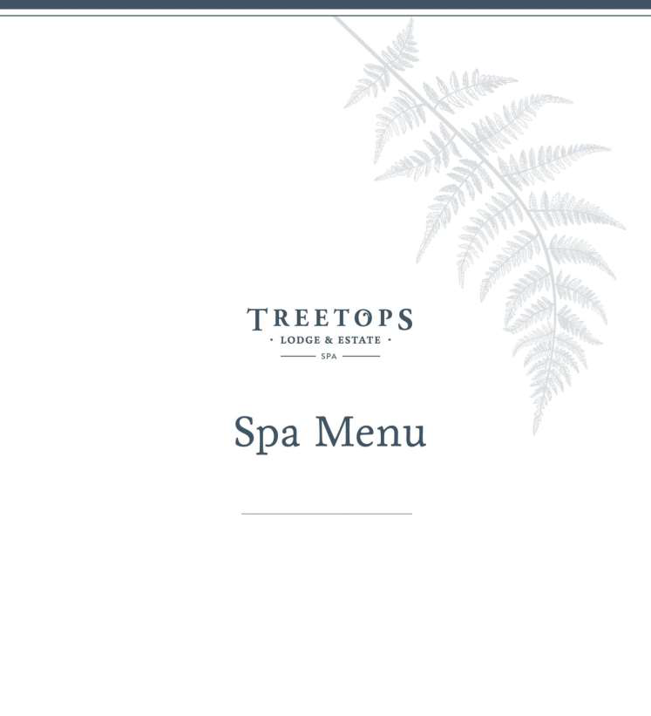

which is Unconditional Love.

Here in Aotearoa, we are intricately connected to the land. Our language and traditions are steeped in healing and spiritual practice, it is an integral part of who we are … without which nothing would adhere. When one partakes of Māori healing, they are also inviting all of the ancestors involved in the healing process. Our Spa at Treetops is a peaceful oasis, with an environment dedicated to tranquillity, relaxation, rejuvenation and wellness.

Further Details

Useful Information

We invite you to join us on this universal waka (path) of sacred healing, with our Signature Treatments.
Signature Treatment
Kaha Ra Mirimiri Massage 90 Minutes | NZD 575 “Kaha Ra Kia whai mana te kikokiko Kia urutae tau Wairua Me whakae te mauri ki nga uru- pounamu e wai-whetu mai I te Ao o tua-rere” (Kaha Ra Empowers the physical body with spiritual consent, blessed by the life essence that shines brightly as the myriads of heavens in the universe) .

‘Kaha’ means strong and ‘Ra’ means light/illumination - a deep and nurturing body therapy that supports the body to release cellular memory, raising its vibration and releasing that which no longer serves us, physically, emotionally and spiritually. Kaha Ra Mirimiri combines traditional indigenous healing methods as follows; Mirimiri (massage) - Mirimiri massage connects with the central nervous system aiding the release of tension and stress, bequeathing you deep relaxation, and a sense of clarity and rejuvenation, Romiromi (deep tissue), Romiromi accesses stimulation points to aid the release of cellular blockages, toxins, pain and extraneous energy, replacing these with positive energy and vitality, Wairuatanga (spirit), Te Whe (sound healing), Wahi Tapu (sacred space), Rongoa (Māori Medicine), sacred geometry, mahana Kohatu (warm Lemurian healing stones), Wai Tai (Sea water) and Wai Tapu (sacred water).

Massage
Enhance your spa experience by arriving earlier to enjoy time in our sauna or take a soothing soak in one of our outdoor hot tubs surrounded with birdsong and the lush beauty of the native bush, prior to or after your massage therapy. Please advise our Staff 1 hour before, if you would like to use the Sauna.

Further Details
Useful Information
Relaxation Massage
60 / 90 Minutes | NZD 280 / NZD 345
Light to medium pressure. A flowing technique to reduce muscular and mental tension, enabling the body to heal itself.
Deep Tissue Massage
60 / 90 Minutes | NZD 300 / 375

Firm pressure. Slow strokes and deep gliding pressure along the muscle length to reduce build-up of accumulated tension in muscles and tissues, using elbows, forearms and knuckles.

Pregnancy Massage 45 Minutes | NZD $260
Pregnancy massages are generally considered safe after the first trimester, as long as you get the green light from your practitioner and you let your massage therapist know you’re pregnant.
Our therapist will make accommodations with a pregnancy mattress that allows you to lie face down safely, while providing room for your growing belly. A relaxing massage to help relieve aches in your back and leg cramps.
Hot Stone Massage 60 / 90 Minutes|NZD 300 / NZD 375 Rebalance your mind, body and soul as the hot stones melt away tense muscles, sore joints and bring balance back to your body. A relaxing treatment, light to medium pressure.
Back, Neck and Shoulder Massage 30 Minutes | NZD 200 A massage that focuses on the key areas that hold stress. Great before or after a round of Golf, Biking, Hiking or if you just have a little time to spare.

Body Treatments
Chocolate & Ylang-Ylang Body Polish 45 Minutes | NZD 270 Chocolate notes combined with feminine, floral scents of Ylang-Ylang. Decadent butters and raw sugar, polish and exfoliate the skin leaving it smooth, nourished and glowing. Extra rich raw Cacao and ylang ylang flowers leave the skin remineralised and deliciously scented.

Coconut and Lime Flower Body Polish 45 Minutes | NZD 270
Uplifting Lime and the scent of Coconut transfer you into that “beautiful summer’s day” feeling. Decadent butters and raw sugar, polish and exfoliate the skin leaving it smooth, nourished and glowing. Essential oils of Lime and Coconut extract revitalise and refresh.
Immune Boosting Rejuvenation Wrap 45 Minutes | NZD 290 Our nourishing immune boosting body wrap is packed with vitamins and minerals, boosting the immune system and is most effective when combined with an exfoliating body polish and an energizing massage to encourage healthy circulation and lymph flow.

Detox Seaweed Body Wrap 45 Minutes | NZD 290 Stimulating and invigorating. Organic seaweed, Centella Asiatica, Guarana extract and essential oils of Cypress, Juniper and Lemon help to encourage lymph flow and toxin removal, promoting a reduction in fat deposit and encourage less edema and cellulite formation.

Further Details

Useful Information

Facials
Rose Balancing Antiaging Facial 60 Minutes | NZD 325 A nurturing and Balancing experience for both body and mind. Rose encourages harmony and wellbeing. The perfect facial for stressed, ageing or hormonal skin.

Remineralising Antioxidant Facial 60 Minutes | NZD325 A vitamin rich and delicious facial using raw cacao to deliver vital vitamins and nutrients to the skin. A combination of free radical fighting, vitamin and mineral rich ingredients, perfect to combat signs of ageing, hydrating the skin and leaving it smooth and glowing.

Radiance Rejuvenating Facial 60 Minutes | NZD 325 A firming and regenerating facial to restore radiance to dull and tired complexions. Increases circulation and refines skin.

Add Ons

Each 20 Minutes | NZD 115

Enhancers Foot Scrub Foot Massage
Warm scalp Massage Back and Neck Massage

Design A Ritual That Suits You

Rewarewa Rejuvention 3 Hours | NZD 740
Scrub: Chocolate & Ylang-Ylang Scrub OR Coconut and Lime Flower Scrub Wrap: Immune Boosting Rejuvenation Wrap OR Detox Seaweed Body Wrap Massage: Relaxing Massage OR Deep Tissue
Facial: Remineralising Antioxidant Facial OR Radiance Rejuvenating Facial

Tranquil Tawa 90 Minutes | NZD 440
Scrub: Chocolate & Ylang-Ylang Scrub OR Coconut and Lime Flower Scrub Massage: Relaxing Massage OR Deep Tissue

The energies that pulsate from this sacred land of Treetops continue to help heal right across Aotearoa, the World and our Universe. MAURI ORA!

Further Details

Useful Information

Cancellation Policy
Should you need to cancel or reschedule, please notify us at least 24 hours in advance. Any cancellations or rescheduling with less than 24 hours of notice or no-show appointments are subject to a cancellation fee amounting to 100% of the cost of the scheduled service.

Reservations
Reservations can be made with one of our team members, directly with the Spa,
by Telephone +64 7 333 2066
|Email reservations@treetops.co.nz

Opening Times Flexible by arrangement

Arrival Clients for the day spa should arrive 10 minutes prior to appointment time. This is
to prepare for your treatment without affecting your treatment time. Please note we adhere
to a prompt appointment schedule. This means
if you arrive late, unfortunately we can offer only
the time remaining of your treatment.

charged at full price. You are most welcome to come in your bathrobe and slippers provided in your room.

Valuables
We recommend not wearing jewellery or valuables. Treetops Lodge & Estate cannot be held responsible for any loss or theft.

Spa Etiquette
The spa is designed for relaxation and tranquillity; therefore, it would be appreciated

Further Details
Useful Information
if you could please refrain from using mobile phones.
Age Requirement
We welcome all ages to the spa but ask that children under 12 are accompanied by an adult.
Health Conditions
Please be sure to tell us about any health conditions, injuries or allergies that could affect your treatment or use of spa facilities when completing the guest questionnaire.

Gift Vouchers
Gift vouchers | Email reservations@treetops.co.nz

All Rates Quoted
All rates quoted include Government Tax. Rates and offered Services are subject to change without any prior notice.

